1. **Which are the top three variables in your model which contribute most towards the probability of a lead getting converted?**

**Ans.** According to the model generated (Model 7), the following variables have been found to have contributed most towards the probability of a lead getting converted:

* 1. **Lead Source_Welingak Website**
  2. **Lead Source_Reference**
  3. **Lead Activity_Had a Phone Conversation**

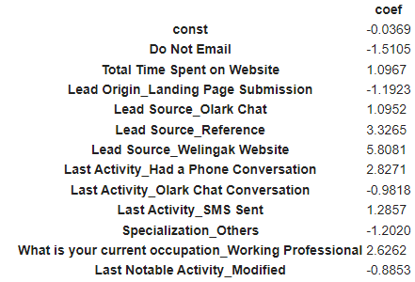

1. **What are the top 3 categorical/dummy variables in the model which should be focused the most on in order to increase the probability of lead conversion?**

**Ans.** The top 3 categorical/dummy variables in the model which should be focused the most on in order to increase the probability of lead conversion are:

* 1. **Lead Source_Welingak Website**
  2. **Lead Source_Reference**
  3. **Last Activity_Had a Phone Conversation**

1. **X Education has a period of 2 months every year during which they hire some interns. The sales team, in particular, has around 10 interns allotted to them. So during this phase, they wish to make the lead conversion more aggressive. So they want almost all of the potential leads (i.e. the customers who have been predicted as 1 by the model) to be converted and hence, want to make phone calls to as much of such people as possible. Suggest a good strategy they should employ at this stage.**

**Ans.** The following few strategies could be employed to increase the conversion rate:

* The sales team should call to people who spends more time on the website.
* The sales team should focus more on the people who come through a reference, as the reference through which they did enquiry can also help in their conversion.
* The working professional has more probability of being converted and hence the working professionals should be focused.
* The candidates who had the last activity of having a phone call seems to have more probability of conversion.

1. **Similarly, at times, the company reaches its target for a quarter before the deadline. During this time, the company wants the sales team to focus on some new work as well. So during this time, the company’s aim is to not make phone calls unless it’s extremely necessary, i.e. they want to minimize the rate of useless phone calls. Suggest a strategy they should employ at this stage.**

**Ans.** The following points should be kept in mind in order to minimize the useless phone calls:

* Students and Unemployed should be avoided.
* People who do not fill specialization have a less probability of getting converted and hence should be avoided.

Submitted by:

Aayushi Singh

Abhijeet Singh